**Exercise 1: Control Structures**

**Scenario 1:** The bank wants to apply a discount to loan interest rates for customers above 60 years old.

**Question:** Write a PL/SQL block that loops through all customers, checks their age, and if they are above 60, apply a 1% discount to their current loan interest rates.

**Solution Script:**

**BEGIN**

**FOR record IN (**

**SELECT L.LoanID**

**FROM Customers C**

**JOIN Loans L ON C.CustomerID = L.CustomerID**

**WHERE MONTHS_BETWEEN(SYSDATE, C.DOB) / 12 > 60**

**FOR UPDATE**

**) LOOP**

**UPDATE Loans**

**SET InterestRate = InterestRate - (InterestRate * 0.01)**

**WHERE LoanID = record.LoanID;**

**END LOOP;**

**COMMIT;**

**DBMS_OUTPUT.PUT_LINE('1% interest discount applied to customers above 60!');**

**END;**

**Output:**

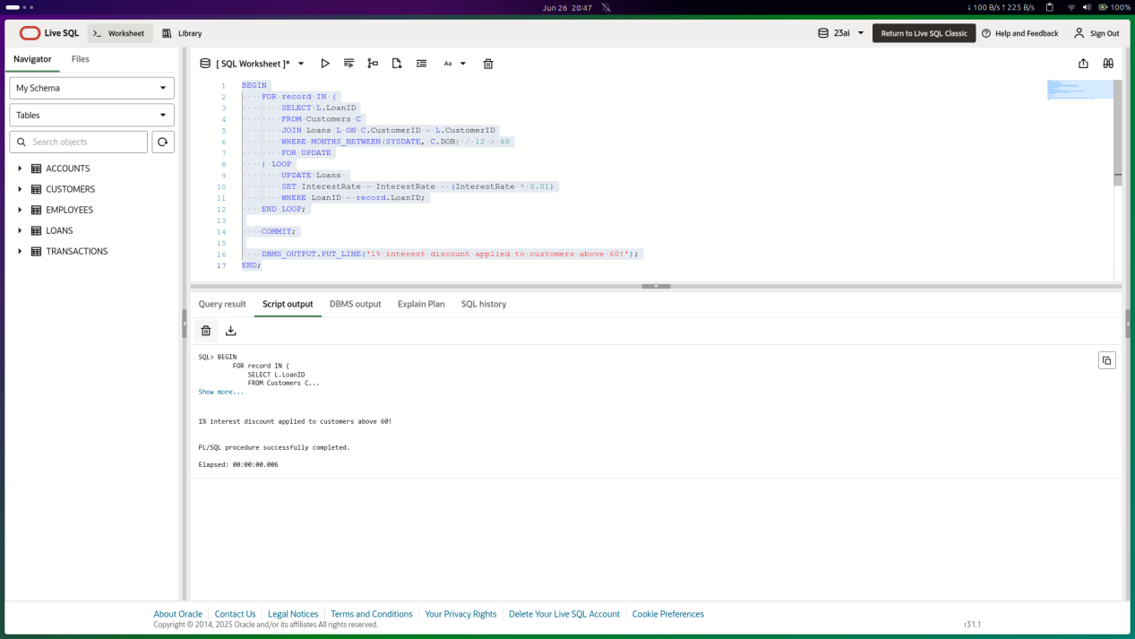

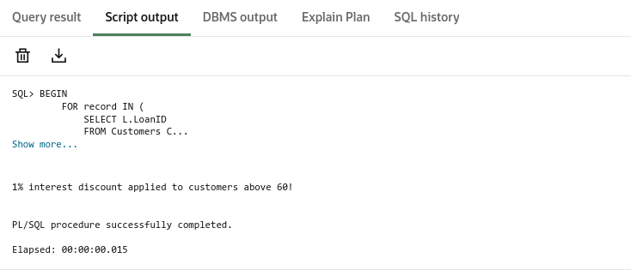

**Scenario 2:** A customer can be promoted to VIP status based on their balance.

**Question:** Write a PL/SQL block that iterates through all customers and sets a flag IsVIP to TRUE for those with a balance over $10,000.

**SOLUTION SCRIPT**

**ALTER TABLE CUSTOMERS**

**ADD ISVIP VARCHAR2(5) DEFAULT 'FALSE';**

**BEGIN**

**FOR RES IN (**

**SELECT CUSTOMERID, BALANCE FROM CUSTOMERS**

**) LOOP**

**IF RES.BALANCE > 10000 THEN**

**UPDATE CUSTOMERS**

**SET ISVIP = 'TRUE'**

**WHERE CUSTOMERID = RES.CUSTOMERID;**

**END IF;**

**END LOOP;**

**COMMIT;**

**END;**

**OUTPUT**

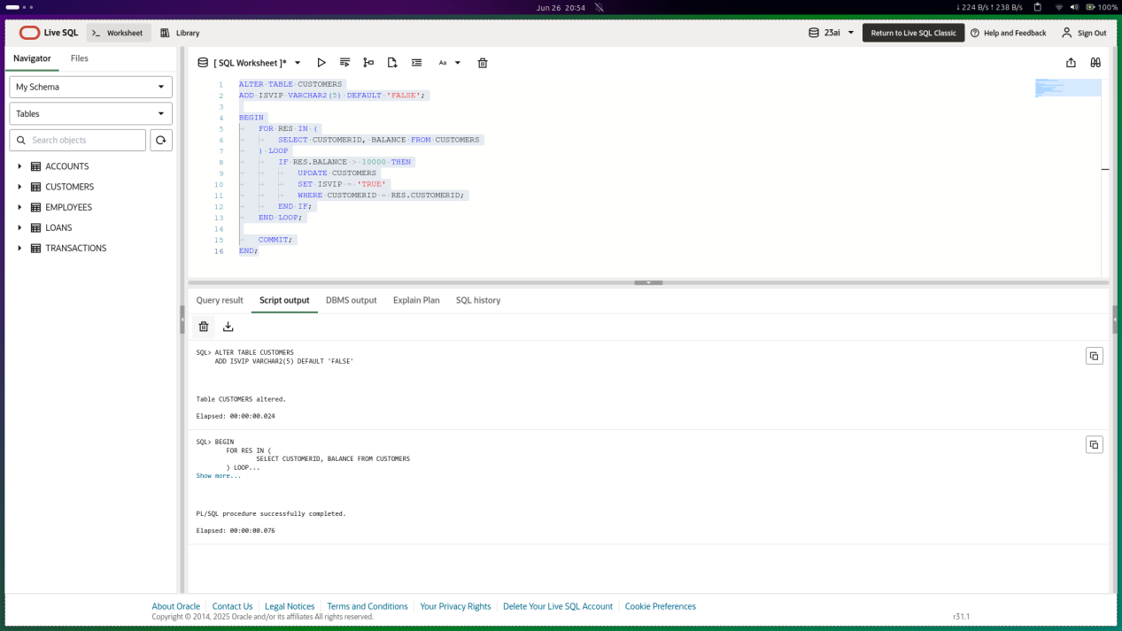

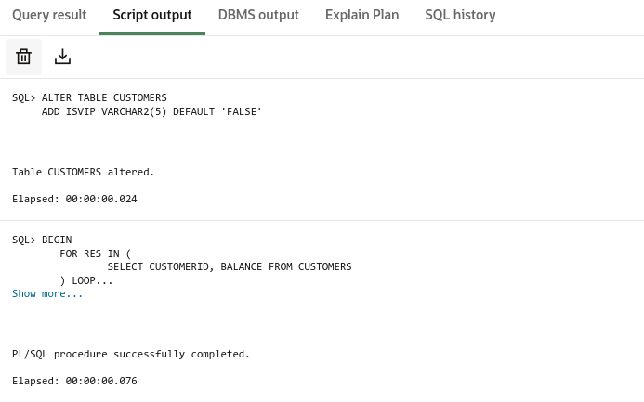

**Scenario 3:** The bank wants to send reminders to customers whose loans are due within the next 30 days.

**Question:** Write a PL/SQL block that fetches all loans due in the next 30 days and prints a reminder message for each customer.

**SOLUTION SCRIPT**

**BEGIN**

**FOR res IN (**

**SELECT C.NAME, C.CUSTOMERID, L.LOANID, L.ENDDATE**

**FROM LOANS L**

**JOIN CUSTOMERS C ON L.CUSTOMERID = C.CUSTOMERID**

**WHERE L.ENDDATE BETWEEN SYSDATE AND SYSDATE + 30**

**) LOOP**

**DBMS_OUTPUT.PUT_LINE(**

**'Reminder: Customer ' || res.NAME ||**

**' (ID: ' || res.CUSTOMERID || ') has a loan due on ' ||**

**TO_CHAR(res.ENDDATE, 'YYYY-MM-DD')**

**);**

**END LOOP;**

**END;**

**/**

**OUTPUT**

